This was the stand-alone rails application (slide tracker) I wrote to track slides as they are delivered to pathologists around the city by the couriers.
This screen shows all the bundles of folders. It shows status, number of folders in the bundle, which pathologist the bundle is for, which courier is assigned to bring it to him (assigned by courier supervisor), and who created the bundle. A bundle is just a stack of folders and each folder can contain up to 20 slides from various cases.
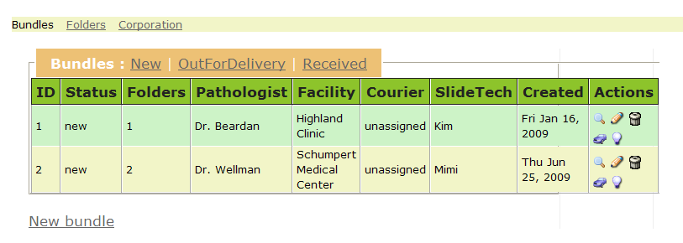
After case slides are through the last part of processing (cover slipping and slide labels), a histologist places these slides in a folder. Here is the creation of a New Bundle of folders to be delivered to a pathologist. Since the folders have a finite number of slide slots, I open up a form with 20 spaces.

Note: the facility is actually the current location of the pathologist. Since pathologists work out of multiple offices, the courier needs to know which facility he is at in order to bring him the bundles.

Slidetech is the staff member (usually a histologist), who is putting the slides into folders.
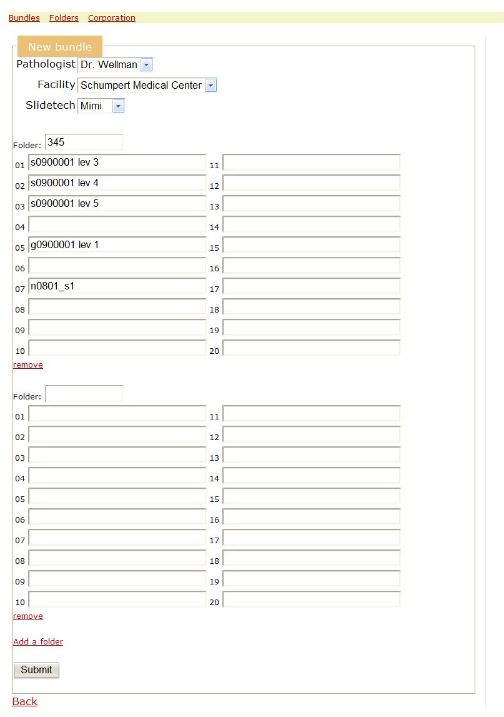
This is a partial picture of a folder that someone put slides into. You can see that the slots are numbered.
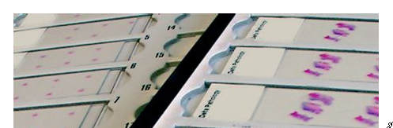

Those are slide labels that will usually have the case number, slide number, barcode. These are printed on a special slide label printer.

This picture below shows you several things
- Here is a picture of a slide label printer.
- This is a cassette printer.
- This is a typical specimen container.
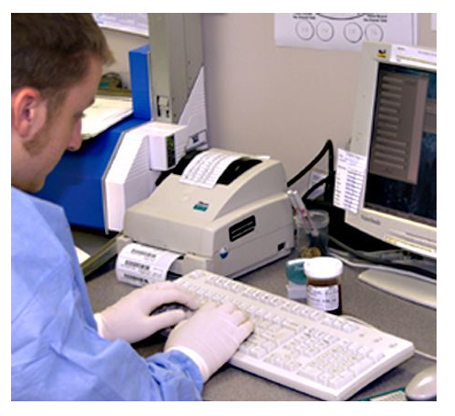
1
3
2

The folders tab shows the folders (there are a finite set of folders that are re-used over and over again). The folder are numbered (that is the name).
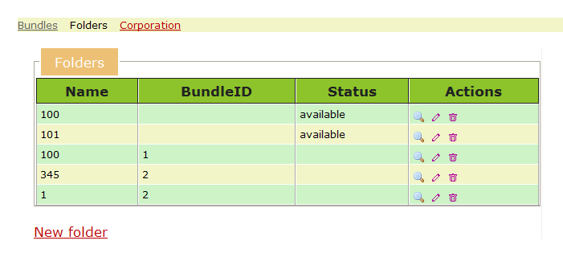
Clicking on details action shows details of the folder.
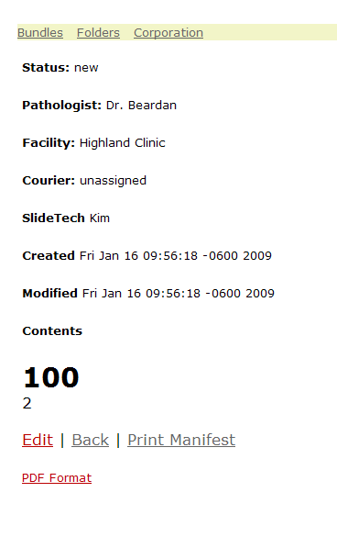
The print manifest would print an invoice that would be placed with the bundle. The manifest shows details like
Pathologist: Dr. Wellman
Schumpert Medical Center
Thu Jun 25, 2009 18:03
Courier Initials : ____
Contents
Some of the actions I had were ‘update status to out for delivery’ which means a courier has taken it and is in transport, and ‘received’ which means the pathologist or the secretary at the facility has received the bundle.

These are unrelated, but here are some pictures to show some of the process stages.
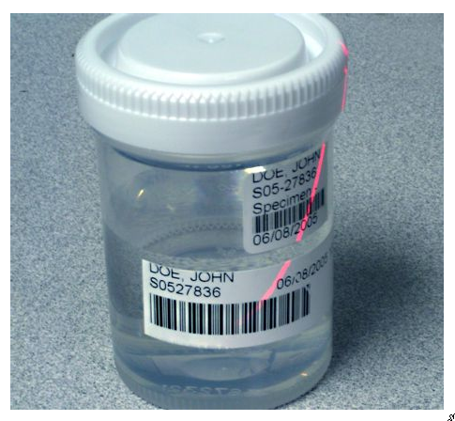
This is a typical specimen container.
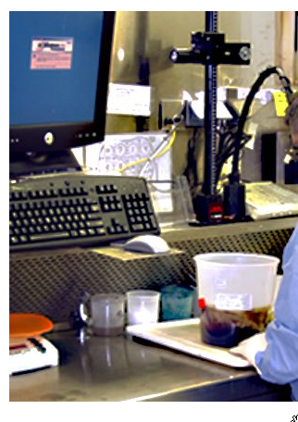
Here you can see a large specimen container that the gross assistant or pathologist or pathologist assistant will cut into pieces. There is a microphone in front of him that he will talk into to create the gross dictation file.

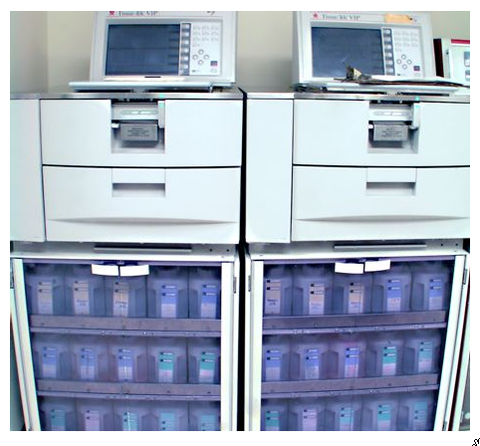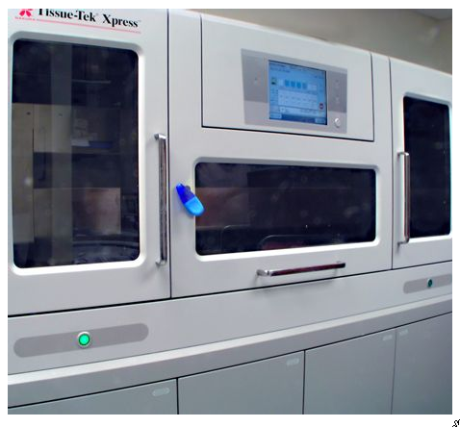
These are tissue processors. The cassettes that come out of the gross stage are placed in them for a period of time to do some chemical changes to the specimens.
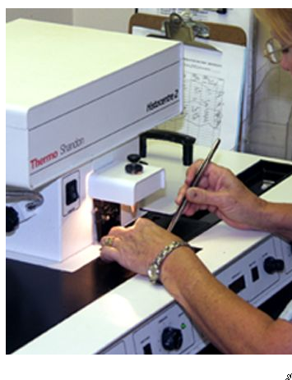
After the tissue processing stage, they enter the embedding stage. In this stage, the specimen is moved from a cassette into a block.
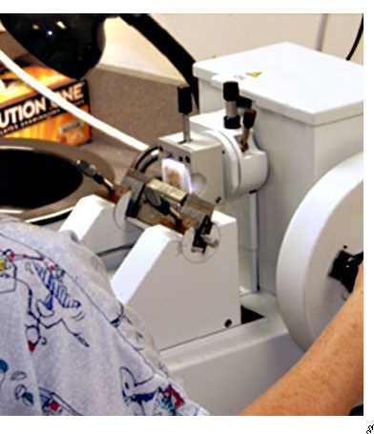
Here you can see a block in the cutting stage, where the histologist shaves the tissue into thin slices to be put on a slides.

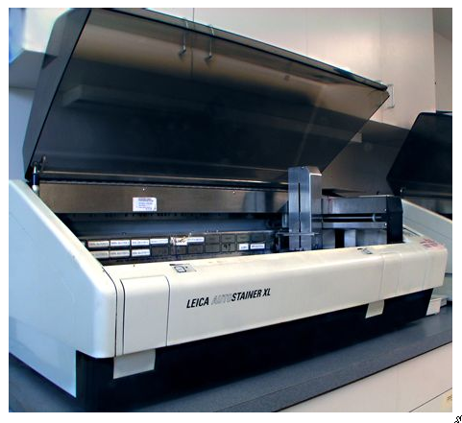
Here is a staining machine. The slides are put in here and stained according to the stains ordered for that particular case.

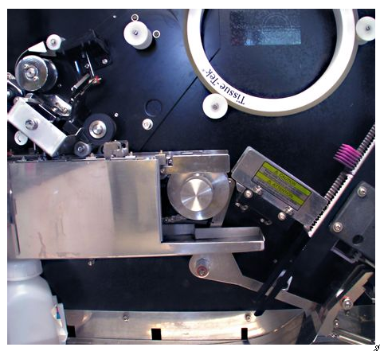
And after staining, the slides enter a cover slipper machine, where the slide is covered with a protective shield.
And then they are labelled and placed in folders to be transported to a waiting pathologist.

